MYSQL QUERY

FOR 𝗮𝘆 𝟮𝟬𝟮𝟱 𝗗𝗮𝘁𝗮𝗗𝗡𝗔 – 𝗠𝗼𝗯𝗶𝗹𝗲 𝗣𝗵𝗼𝗻𝗲 𝗦𝗮𝗹𝗲𝘀 𝗔𝗻𝗮𝗹𝘆𝘀𝗶𝘀 project

1 -- • Which mobile brands and models are the top sellers overall and in specific countries or cities?(most popular by volume)

select Mobile_Model,Brand,Country,City,sum(Units_Sold) as Total_units

from facts_sales

group by Mobile_Model,Brand,Country,City

order by Total_units desc

limit 5;

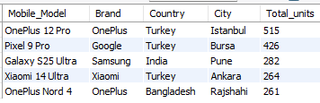

-- alternative approach,Which mobile brands and models are the top sellers overall and in specific countries or cities?(highest revenue generated)

select Mobile_Model,Brand,Country,City,sum(Total_Revenue) as Total_Revenue

from facts_sales

group by Mobile_Model,Brand,Country,City

order by Total_Revenue desc

limit5;

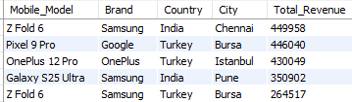

2 -- How do sales numbers vary by storage size, color, or operating system (Android vs. iOS)?

select Storage_Size,Color,Operating_System, sum(Units_Sold) as Total_units

from facts_sales

group by Storage_Size,Color,Operating_System

order by Total_units desc

limit 5

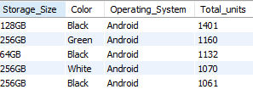

3 -- What is the typical customer profile — age group, gender — for different brands or models?

SELECT Brand, Mobile_Model,

Customer_Age_Group, Customer_Gender,

COUNT(Transaction_ID) AS Total_Transactions,

SUM(Units_Sold) AS Total_Units_Sold,

SUM(Total_Revenue) AS Total_Revenue

FROM facts_sales

GROUP BY Brand, Mobile_Model,

Customer_Age_Group, Customer_Gender

ORDER BY Total_Units_Sold DESC

LIMIT 5;

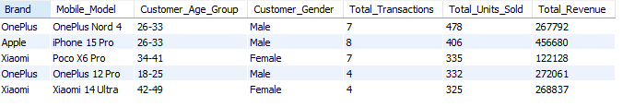

4 -- How do sales and revenues break down across different sales channels (online, partner, in-store) and payment types?

select Sales_Channel,Payment_Type,sum(Total_Revenue) as Total_revenue,

sum(Units_Sold) as Total_units, COUNT(Transaction_ID) AS Total_Transactions

from facts_sales

group by Sales_Channel,Payment_Type

order by Total_revenue desc, Total_units desc

limit 5;

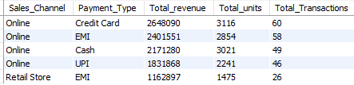

* 4 --- Are there noticeable differences in pricing and sales volume between regions or cities?

To check if pricing varies across locations:

SELECT Country, City,

AVG(Price) AS Avg_Price,

SUM(Units_Sold) AS Total_Units_Sold

FROM facts_sales

GROUP BY Country, City

ORDER BY Avg_Price DESC

limit 5;

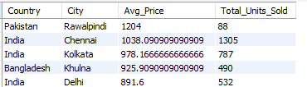

5 -- • Which countries or cities generate the highest total revenue and units sold?

select Country,City,

sum(Units_Sold)as Total_units,

sum(Total_Revenue)as Total_Revenue

from facts_sales

group by Country,City

order by Total_units desc,Total_Revenue desc

limit 5;

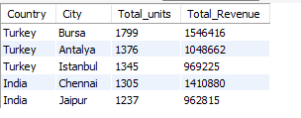

6 -- Are there correlations between customer age groups and the type of devices they purchase (for example, younger customers preferring certain brands)?

SELECT

Customer_Age_Group, Customer_Gender,

Brand, Mobile_Model,Color,

COUNT(Transaction_ID) AS Total_Transactions,

SUM(Units_Sold) AS Total_Units_Sold,

SUM(Total_Revenue) AS Total_Revenue,

avg(price)as avg_price

FROM facts_sales

GROUP BY Customer_Age_Group, Customer_Gender,

Brand, Mobile_Model,Color

ORDER BY Total_Units_Sold DESC

LIMIT 5;

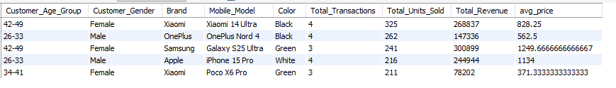

* 7 How does sales performance change month over month in 2024?

SELECT DATE_FORMAT(Transaction_Date, '%Y-%m') AS Month,

SUM(Units_Sold) AS Total_Units_Sold,

SUM(Total_Revenue) AS Total_Revenue

FROM facts_sales

WHERE YEAR(Transaction_Date) = 2024

GROUP BY Month

ORDER BY Month ASC;

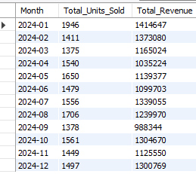

Or

SELECT

DATE_FORMAT(Transaction_Date, '%Y-%m') AS month,

SUM(Units_Sold) AS total_sales,

LAG(SUM(Units_Sold)) OVER (ORDER BY DATE_FORMAT(Transaction_Date, '%Y-%m')) AS prev_month_sales,

(SUM(Units_Sold) - LAG(SUM(Units_Sold)) OVER (ORDER BY DATE_FORMAT(Transaction_Date, '%Y-%m'))) AS sales_change,

ROUND(

100.0 * (SUM(Units_Sold) - LAG(SUM(Units_Sold)) OVER (ORDER BY DATE_FORMAT(Transaction_Date, '%Y-%m'))) /

NULLIF(LAG(SUM(Units_Sold)) OVER (ORDER BY DATE_FORMAT(Transaction_Date, '%Y-%m')), 0), 2

) AS pct_change

FROM facts_sales

WHERE YEAR(Transaction_Date) = 2024

GROUP BY DATE_FORMAT(Transaction_Date, '%Y-%m')

ORDER BY month;

